Bellevue University

**Module 11**

**Milestone 3**

Ricardo Orlando, Monica Jones, Donnell Perkins

Database Development and Use – CSD310-307

Instructor: Tracy Shelanskey

Due: 05/07/2023

**Case Study 1 – Bacchus Winery**

This report will include the employee's name, position, position type, and hours. This provides an answer to how many hours an employee has worked.

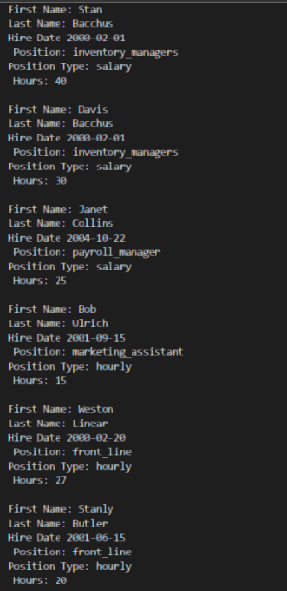

This report with show the total number of orders for all product sales. They would be used to see the total volume of sales of the company.

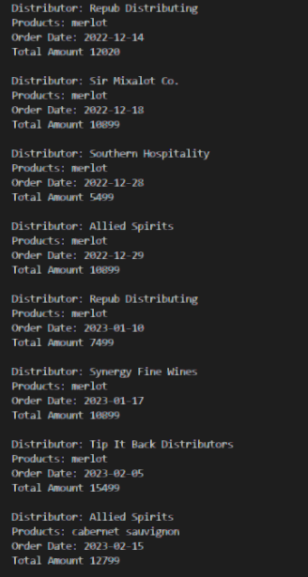

This report will show the expected vs the actual delivery dates and the issues with supply orders.

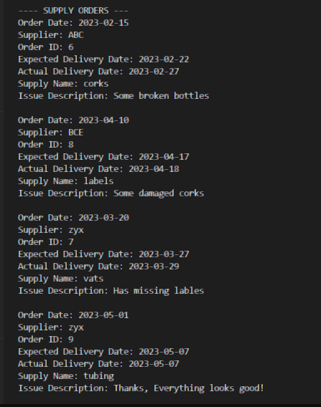

This is another sales report based on a single product order volume.

